

Федеральное государственное автономное образовательное учреждение высшего образования

«Национальный исследовательский университет ИТМО»

Факультет ПИ и КТ

Лабораторная работа №4

по дисциплине: «Вычислительная математика»

«Аппроксимация функции»

Вариант 1

Выполнил:

**Болорболд Аригуун**,

группа P3211

Преподаватель:

**Малышева Татьяна Алексеевна**

Санкт-Петербург

2024



1. **Цель работы:**

Найти функцию, являющуюся наилучшим приближением заданной табличной функции по методу наименьших квадратов.

1. **Вычислительная реализация задачи:**

Линейная аппроксимация:

|  |  |  |  |  |  |  |  |  |  |  |  |
| --- | --- | --- | --- | --- | --- | --- | --- | --- | --- | --- | --- |
|  | *1* | *2* | *3* | *4* | *5* | *6* | *7* | *8* | *9* | *10* | *11* |
|  | *–2* | *–1,8* | *–1,6* | *–1,4* | *–1,2* | *–1,0* | *–0,8* | *–0,6* | *–0,4* | *–0,2* | *0* |
|  | *–1,412* | *–1,879* | *–2,542* | *–3,47* | *–4,685* | *–6* | *–6,81* | *–6,374* | *–4,68* | *–2,396* | *0* |

Вычисляем суммы:

|  |  |  |  |  |  |  |  |  |  |  |  |
| --- | --- | --- | --- | --- | --- | --- | --- | --- | --- | --- | --- |
|  | *–2* | *–1,8* | *–1,6* | *–1,4* | *–1,2* | *–1,0* | *–0,8* | *–0,6* | *–0,4* | *–0,2* | *0* |
|  | *–1,412* | *–1,879* | *–2,542* | *–3,47* | *–4,685* | *–6* | *–6,81* | *–6,374* | *–4,68* | *–2,396* | *0* |
|  | *7,743* | *6,926* | *6,109* | *5,293* | *4,476* | *3,659* | *2,842* | *2,025* | *1,209* | *0,392* | *–0,425* |
|  | *83,814* | *77,528* | *74,84* | *76,79* | *83,924* | *93,296* | *93,161* | *70,543* | *34,68* | *7,773* | *0,181* |

Квадратичная аппроксимация:

|  |  |  |  |  |  |  |  |  |  |  |  |
| --- | --- | --- | --- | --- | --- | --- | --- | --- | --- | --- | --- |
|  | *1* | *2* | *3* | *4* | *5* | *6* | *7* | *8* | *9* | *10* | *11* |
|  | *–2* | *–1,8* | *–1,6* | *–1,4* | *–1,2* | *–1,0* | *–0,8* | *–0,6* | *–0,4* | *–0,2* | *0* |
|  | *–1,412* | *–1,879* | *–2,542* | *–3,47* | *–4,685* | *–6* | *–6,81* | *–6,374* | *–4,68* | *–2,396* | *0* |

Вычисляем суммы:

|  |  |  |  |  |  |  |  |  |  |  |  |
| --- | --- | --- | --- | --- | --- | --- | --- | --- | --- | --- | --- |
|  | *–2* | *–1,8* | *–1,6* | *–1,4* | *–1,2* | *–1,0* | *–0,8* | *–0,6* | *–0,4* | *–0,2* | *0* |
|  | *–1,412* | *–1,879* | *–2,542* | *–3,47* | *–4,685* | *–6* | *–6,81* | *–6,374* | *–4,68* | *–2,396* | *0* |
|  | *–0,035* | *–2,039* | *–3,616* | *–4,767* | *–5,492* | *–5,79* | *–5,662* | *–5,108* | *–4,127* | *–2,72* | *–0,887* |
|  | *1,896* | *0,026* | *1,153* | *1,682* | *0,651* | *0,044* | *1,318* | *1,603* | *0,306* | *0,105* | *0,787* |

У квадратичной аппроксимации среднеквадратичное отклонение меньше, поэтому это приближение лучшее.

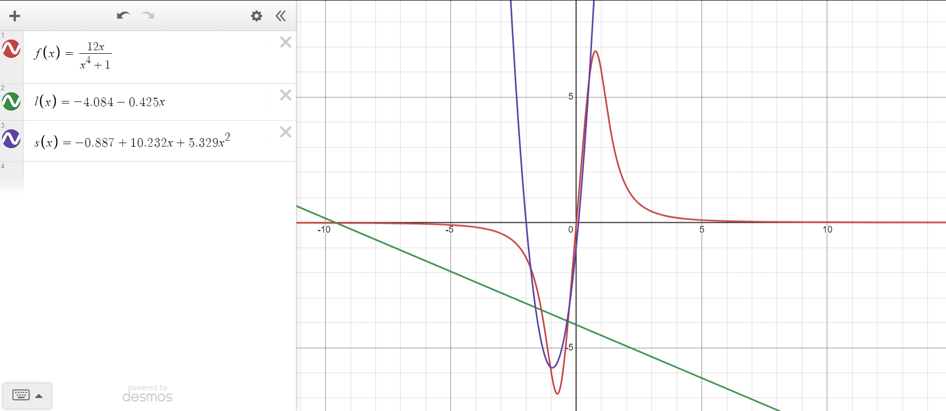

1. **Программная реализация задачи:**

import inspect  
from math import sqrt, exp, log  
  
import matplotlib.pyplot as plt  
  
def add_col(m, col):  
 for k, row in enumerate(m):  
 row.append(col[k])  
 return m  
  
def remove_last_col(m):  
 for k, row in enumerate(m):  
 row.pop()  
 return m  
  
def plus(src, ind, m):  
 for i in range(src + 1, len(m)):  
 _plus(src, i, m, -m[i][ind] / m[src][ind])  
  
def _plus(src, dest, m, mul: float = 1):  
 for i in range(len(m[0])):  
 m[dest][i] += m[src][i] * mul  
  
def swap(src, dest, m):  
 m[src], m[dest] = m[dest], m[src]  
  
def rang(m):  
 return sum(any(row) for row in m)  
  
def determinant(m, k):  
 p = 1  
 for i in range(len(m)):  
 p *= m[i][i]  
 return (-1) ** k * p  
  
def solve(m):  
 k = 0  
 row = 0  
 col = 0  
 n = len(m)  
 while col < n:  
 for j in range(row, n):  
 if m[j][col]:  
 swap(j, row, m)  
 k += row != j  
 plus(row, col, m)  
 row += 1  
 break  
 col += 1  
 xs = []  
 for i in range(len(m)):  
 x = m[len(m) - i - 1][-1]  
 for j in range(1, i + 2):  
 if j == i + 1:  
 x /= m[len(m) - i - 1][-j - 1]  
 else:  
 x -= m[len(m) - i - 1][-j - 1] * xs[j - 1]  
 xs.append(x)  
 return xs[::-1]  
  
def summator_of_exponents(arr, exp: int):  
 res = []  
 for i in range(1, exp + 1):  
 res.append(sum(a ** i for a in arr))  
 return res  
  
def summator_of_products(arr1, arr2, exp: int):  
 res = []  
 for i in range(exp + 1):  
 res.append(sum(x ** i * y for x, y in zip(arr1, arr2)))  
 return res  
def linear_approximation(xs, ys, n):  
 args = summator_of_exponents(xs, 2)  
 vals = summator_of_products(xs, ys, 1)  
 ext_matrix = add_col(  
 [  
 [n, args[0]],  
 [args[0], args[1]]  
 ],  
 [vals[0], vals[1]]  
 )  
  
 a, b = solve(ext_matrix)  
 return lambda x: a + b * x, a, b  
def quadratic_approximation(xs, ys, n):  
 args = summator_of_exponents(xs, 4)  
 vals = summator_of_products(xs, ys, 2)  
 ext_matrix = add_col(  
 [  
 [n, args[0], args[1]],  
 [args[0], args[1], args[2]],  
 [args[1], args[2], args[3]]  
 ],  
 [vals[0], vals[1], vals[2]]  
 )  
  
 a, b, c = solve(ext_matrix)  
 return lambda x: a + b * x + c * x ** 2, a, b, c  
  
def cubic_approximation(xs, ys, n):  
 args = summator_of_exponents(xs, 6)  
 vals = summator_of_products(xs, ys, 3)  
 ext_matrix = add_col(  
 [  
 [n, args[0], args[1], args[2]],  
 [args[0], args[1], args[2], args[3]],  
 [args[1], args[2], args[3], args[4]],  
 [args[2], args[3], args[4], args[5]]  
 ],  
 [vals[0], vals[1], vals[2], vals[3]]  
 )  
  
 a, b, c, d = solve(ext_matrix)  
 return lambda x: a + b * x + c * x ** 2 + d * x ** 3, \  
 a, b, c, d  
  
def exponential_approximation(xs, ys, n):  
 ys_ = list(map(log, ys))  
 _, a_, b_ = linear_approximation(xs, ys_, n)  
 a = exp(a_)  
 b = b_  
 return lambda x: a * exp(b * x), a, b  
  
def logarithmic_approximation(xs, ys, n):  
 xs_ = list(map(log, xs))  
 _, a_, b_ = linear_approximation(xs_, ys, n)  
 a = a_  
 b = b_  
 return lambda x: a + b * log(x), a, b  
  
def power_approximation(xs, ys, n):  
 xs_ = list(map(log, xs))  
 ys_ = list(map(log, ys))  
 _, a_, b_ = linear_approximation(xs_, ys_, n)  
 a = exp(a_)  
 b = b_  
 return lambda x: a * x ** b, a, b  
  
def calc_deviation(xs, ys, fi):  
 return sum((eps ** 2 for eps in [fi(x) - y for x, y in zip(xs, ys)]))  
  
def calc_standard_deviation(xs, ys, fi, n):  
 return sqrt(sum(((fi(x) - y) ** 2 for x, y in zip(xs, ys))) / n)  
  
def calc_pearson_correlation_coefficient(xs, ys, n):  
 av_x, av_y = sum(xs) / n, sum(ys) / n  
 return sum((x - av_x) * (y - av_y) for x, y in zip(xs, ys)) / \  
 sqrt(sum((x - av_x) ** 2 for x in xs) *  
 sum((y - av_y) ** 2 for y in ys))  
  
def calc_coefficient_of_determination(xs, ys, fi, n):  
 return 1 - sum((y - fi(x)) ** 2 for x, y in zip(xs, ys)) / (sum(fi(x) ** 2 for x in xs) - sum(fi(x) for x in xs) ** 2 / n)  
  
def get_str_content_of_func(func):  
 str_func = inspect.getsourcelines(func)[0][0]  
 return str_func.split('lambda x: ')[-1].split(',')[0].strip()  
  
def draw_plot(a, b, func, dx=0.1):  
 xs, ys = [], []  
 a -= dx  
 b += dx  
 x = a  
 while x <= b:  
 xs.append(x)  
 ys.append(func(x))  
 x += dx  
 plt.plot(xs, ys, 'g')  
  
def read_number(s: str):  
 while True:  
 try:  
 return float(input(s))  
 except ValueError:  
 continue  
  
if __name__ == '__main__':  
 read_number("Введите количество точек: ")  
 xs = list(map(float, input("x: ").split()))  
 ys = list(map(float, input("y: ").split()))  
 if len(xs) != len(ys):  
 print("Некорректные данные")  
 n = len(xs)  
 names = {  
 linear_approximation: "Линейная",  
 power_approximation: "Степенная",  
 exponential_approximation: "Экспоненциальная",  
 logarithmic_approximation: "Логарифмическая",  
 quadratic_approximation: "Квадратичная",  
 cubic_approximation: "Кубическая"  
 }  
 if all(map(lambda x: x > 0, xs)) and all(map(lambda x: x > 0, ys)):  
 approximation_funcs = [  
 linear_approximation,  
 power_approximation,  
 exponential_approximation,  
 logarithmic_approximation,  
 quadratic_approximation,  
 cubic_approximation  
 ]  
 else:  
 approximation_funcs = [  
 linear_approximation,  
 quadratic_approximation,  
 cubic_approximation  
 ]  
 best_sigma = float('inf')  
 best_apprxmt_f = None  
 for apprxmt_f in approximation_funcs:  
 print(names[apprxmt_f], ": ")  
 fi, *coeffs = apprxmt_f(xs, ys, n)  
 s = calc_deviation(xs, ys, fi)  
 sigma = calc_standard_deviation(xs, ys, fi, n)  
 if sigma < best_sigma:  
 best_sigma = sigma  
 best_apprxmt_f = apprxmt_f  
 r2 = calc_coefficient_of_determination(xs, ys, fi, n)  
 print('fi(x) =', get_str_content_of_func(fi))  
 print(f'coeffs:', list(map(lambda cf: round(cf, 4), coeffs)))  
 print(f'S = {s:.5f}, σ = {sigma:.5f}, R^2 = {r2:.5f}')  
 if apprxmt_f is linear_approximation:  
 print('r =', calc_pearson_correlation_coefficient(xs, ys, n))  
 plt.title(names[apprxmt_f])  
 draw_plot(xs[0], xs[-1], fi)  
 for i in range(n):  
 plt.scatter(xs[i], ys[i], c='r')  
 plt.xlabel("X")  
 plt.ylabel("Y")  
 plt.show()  
 print('-' * 50)  
 print(f'Лучшая функция: {names[best_apprxmt_f]}')

1. **Тестовые данные и сравнение с десмосом:**

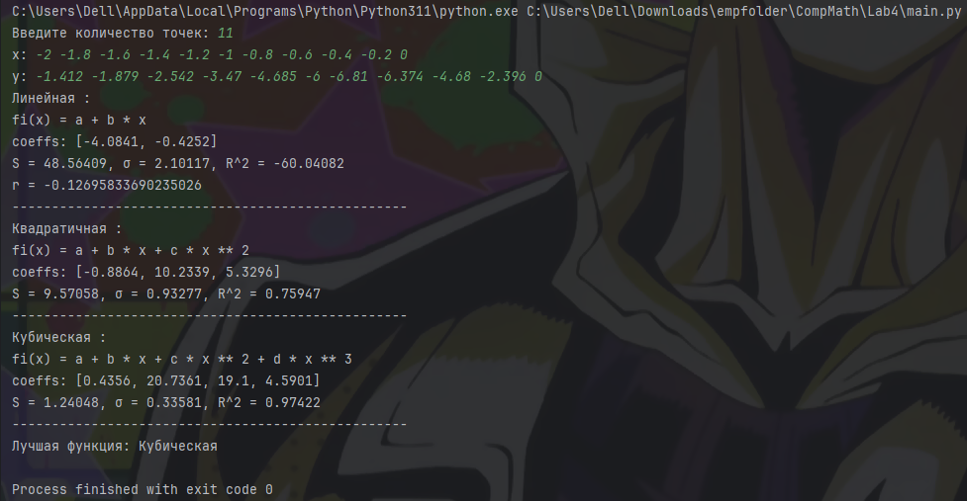

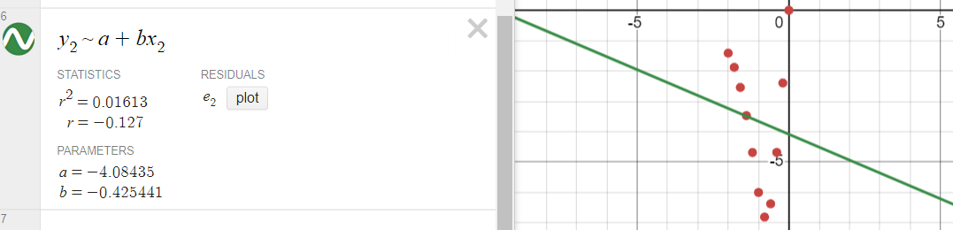

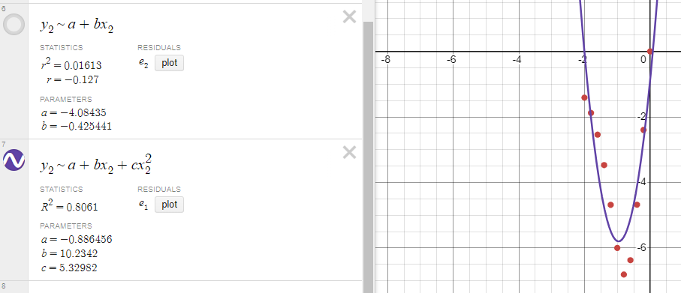

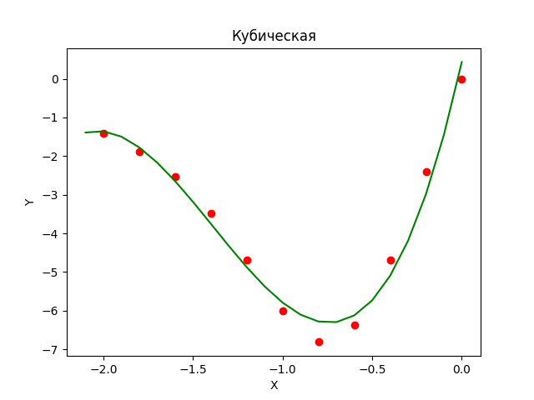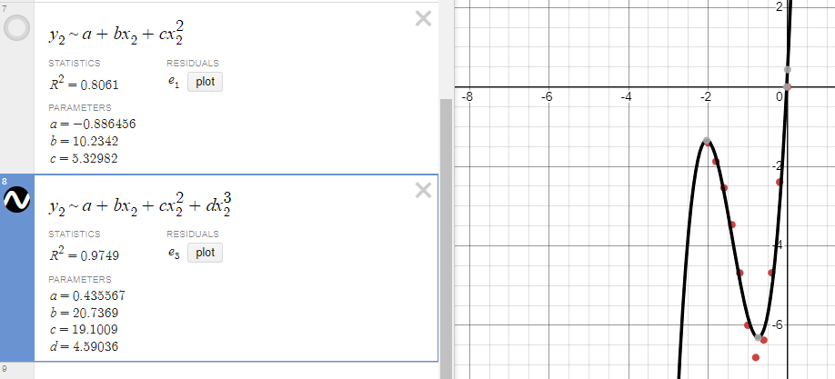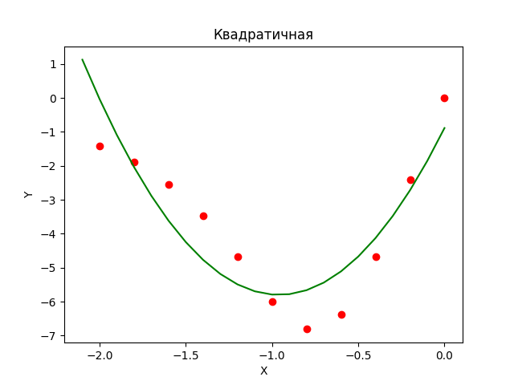

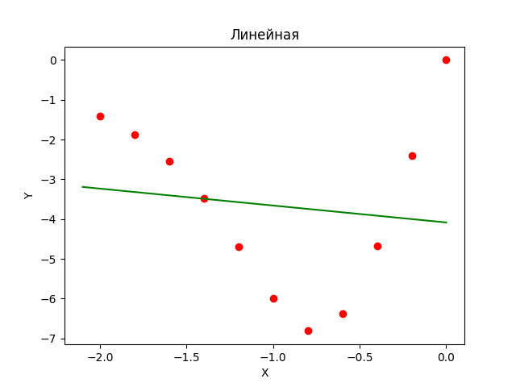

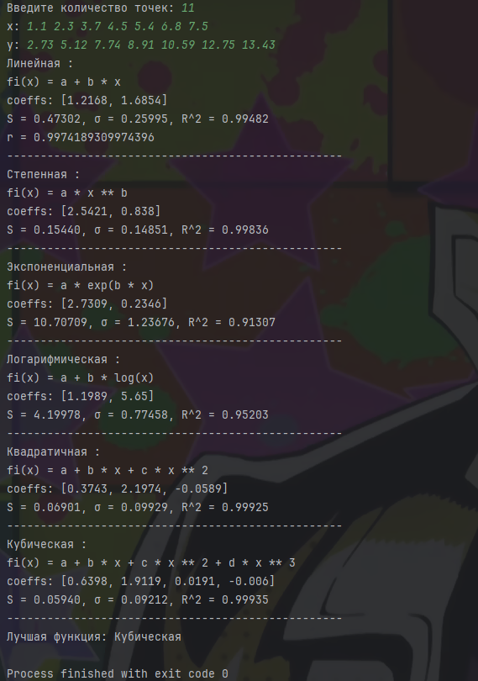



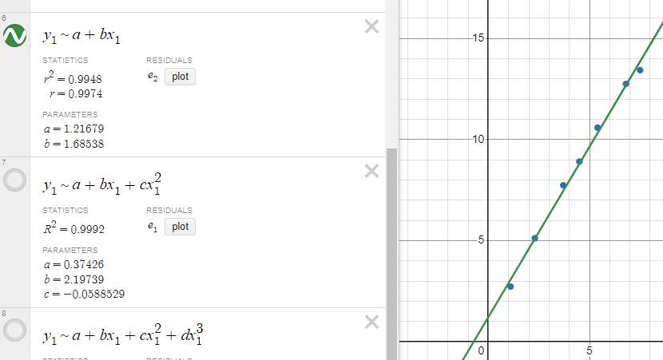

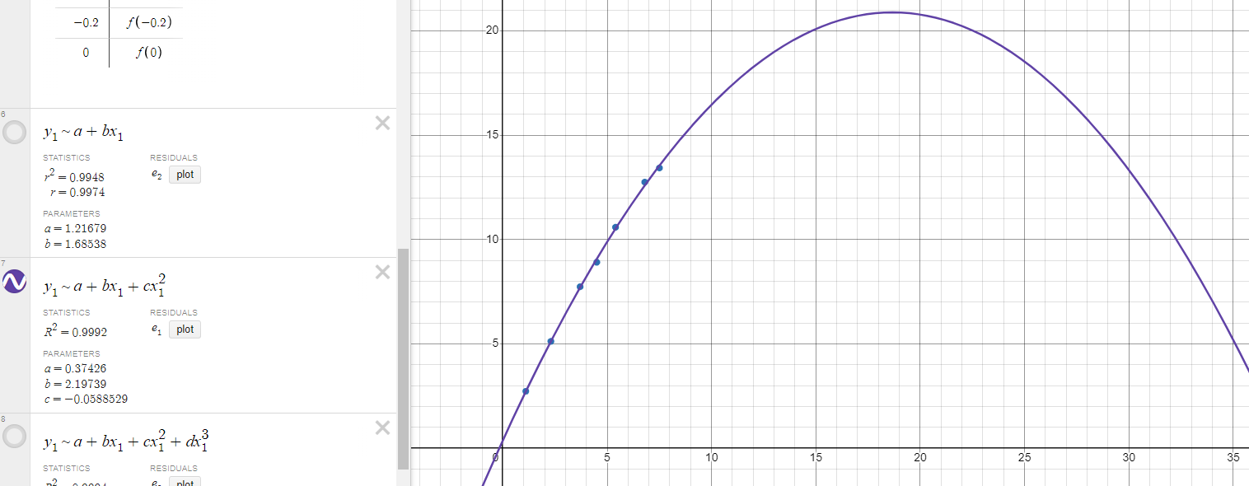

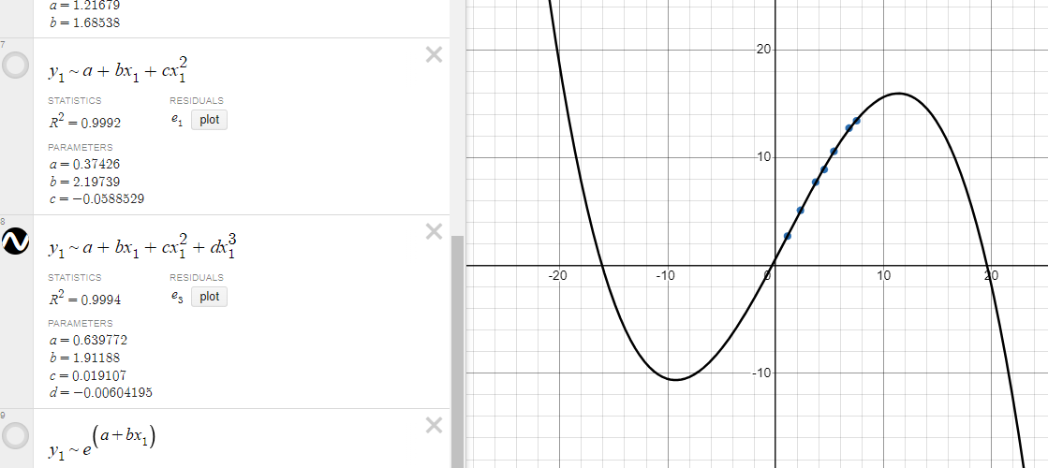

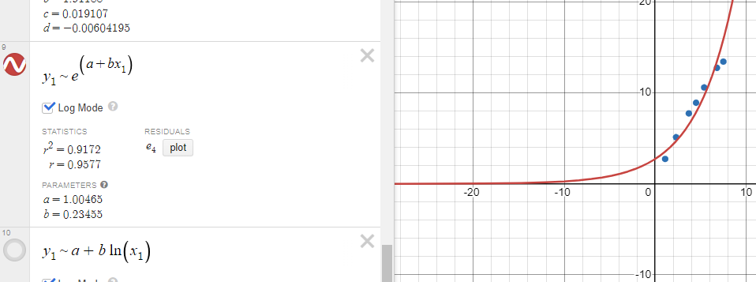

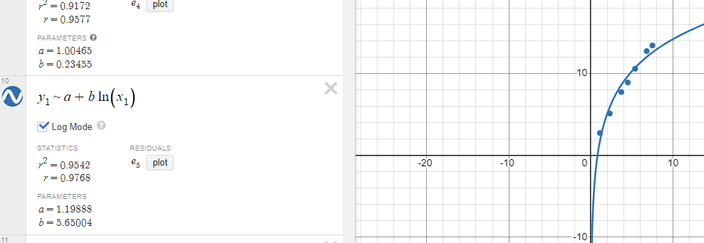

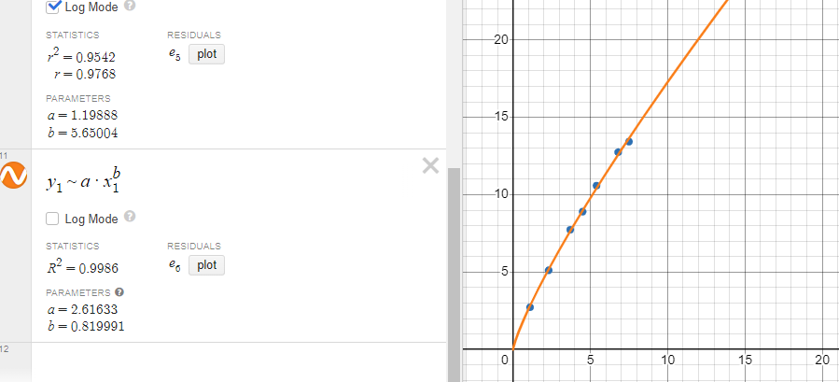

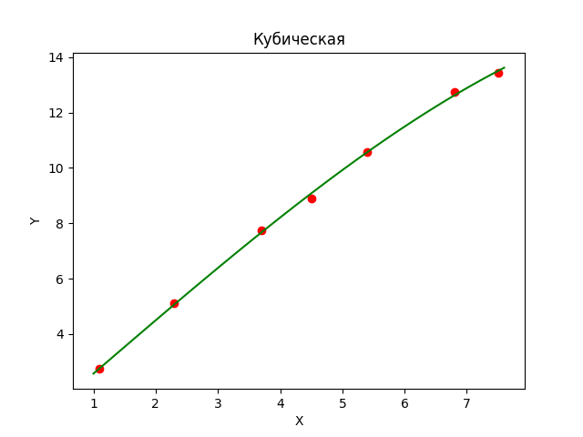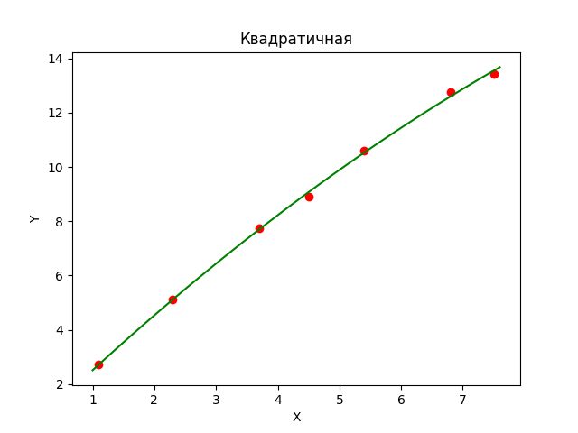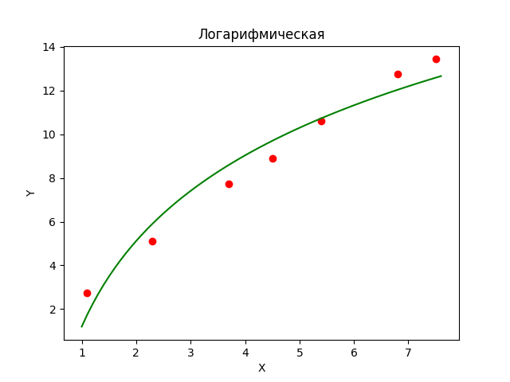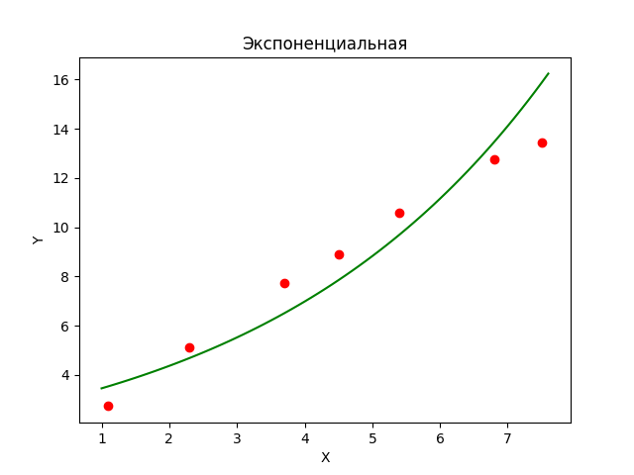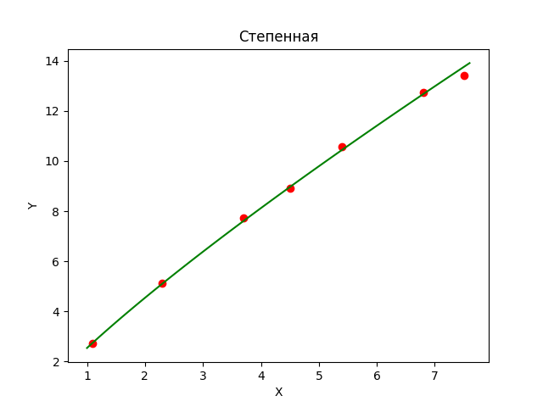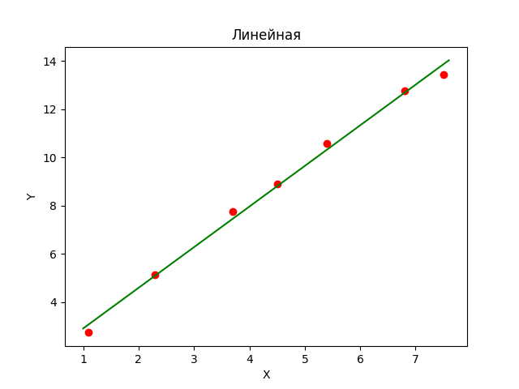

1. **Выводы:**

В ходе лабораторной работы я познакомился с аппроксимацией функции методом наименьших квадратов.

Сам МНК — хороший метод, где определяются параметры, при которых значения аппроксимирующей функции приблизительно совпадали бы со значениями исходной функции. В качестве аппроксимирующих функций обычно берут многочлены. Чем выше степень многочлена, тем точнее. Можно использовать экспоненциальные, логарифмические, степенные функции (сводя их преобразованиями к линейному аппроксимированию). Аппроксимирующая функций проходит в минимальной расстоянии от точек из заданного массива данных.